Assignment - 6

1. Install React Router by installing react-router-dom

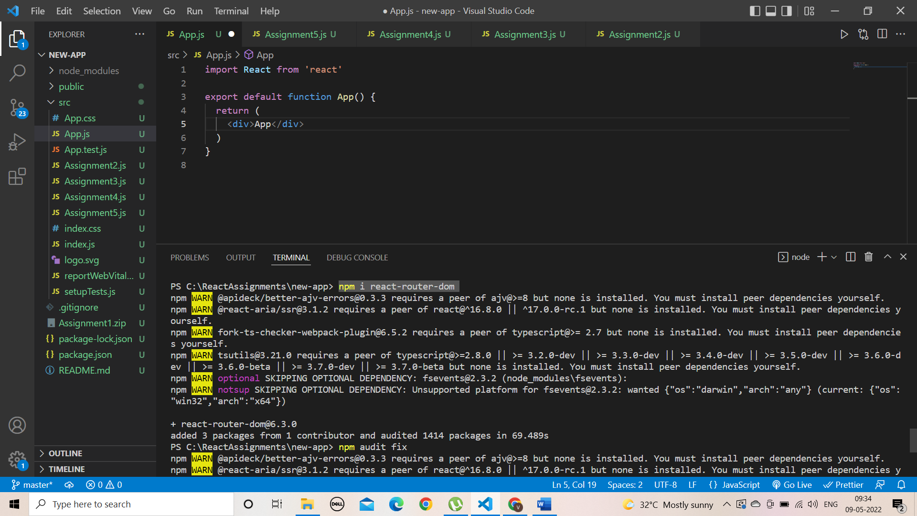

2. Using link create a Home tag .create this tag importing

{Link) from react-router-dom

App.js:-

import { BrowserRouter, Routes, Route } from "react-router-dom";

import Home from "./Home";

function App() {

  return (

    <BrowserRouter>

      <Routes>

        <Route path="/" element={<Home />} />

      </Routes>

    </BrowserRouter>

  );

}

export default App;

Home.js:-

import React from "react";

export default function Home() {

  return <div>Home</div>;

}

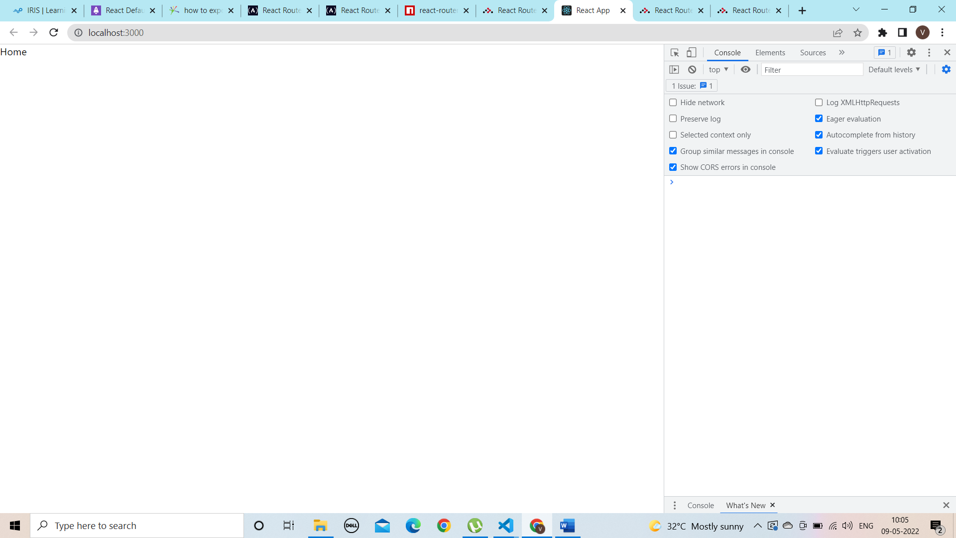

3. Display a page not found error message 404 if any one navigate to a page which

is not found.

